**Sign in to Intune in the Microsoft Endpoint Manager admin center**

If you're not already signed in to the portal, complete the following steps:

1. Open a new browser window and enter [**https://endpoint.microsoft.com**](https://endpoint.microsoft.com/) in the address bar.
2. Use the user ID that you were given in the steps above to sign in. The user ID will look similar to the following: *yourID@yourdomain.onmicrosoft.com*.

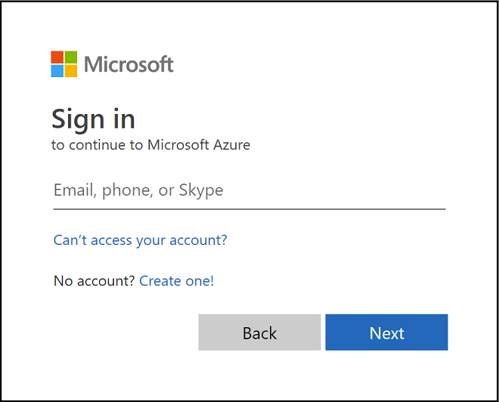

When you sign up for a trial, you will also receive an email message that contains your account information and the email address that you provided during the sign-up process. This email confirms your trial is active.

**Tip:** When working with the Microsoft Endpoint Manager, you may have better results working with a browser in regular mode, rather than private mode.

**Confirm the MDM authority in Microsoft Endpoint Manager**

By default, the Mobile Device Management (MDM) authority is set when you create your free trial. You can confirm that the MDM authority is set by using the following steps:

1. If you're not already signed in, sign in to the [Microsoft Endpoint Manager admin center](https://endpoint.microsoft.com/).
2. Click **Tenant administration**.
3. View the tenant details. The **MDM authority** should be set to **Microsoft Intune**.

If after signing in to the Microsoft Endpoint Manager, you see an orange banner indicating that you haven't yet set the MDM authority, you can activate it at this time. The mobile device management (MDM) authority setting determines how you manage your devices. The MDM authority must be set before users can enroll devices for management.

**Set the MDM authority to Intune**

1. If you do not have the MEM authority set, sign in to the [Microsoft Endpoint Manager admin center](https://endpoint.microsoft.com/).
2. Select the orange banner to open the **Mobile Device Management Authority** setting. The orange banner is only displayed if you haven't yet set the MDM authority.

**Note**

If you have set the MDM Authority, you will see the MDM authority value on the **Tenant administration** pane. The orange banner is only displayed if you haven't yet set the MDM authority.

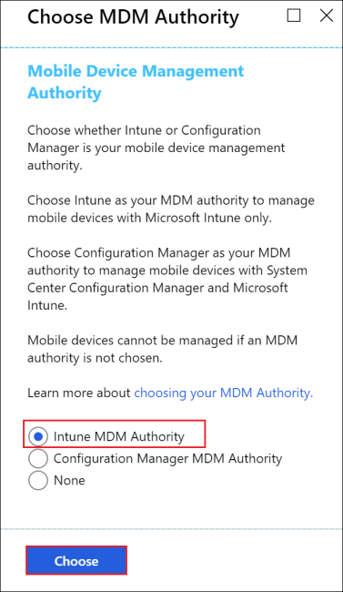

1. If your MDM Authority is not set, under **Choose MDM Authority**, set your MDM authority to **Intune MDM Authority**.

For more information about the MDM authority, see [Set the mobile device management authority](https://docs.microsoft.com/en-us/mem/intune/fundamentals/mdm-authority-set).

**Configure your custom domain name (Optional)**

As mentioned above, if your organization has its own custom domain that you want to use without **.onmicrosoft.com**, you can change it in the Microsoft 365 admin center. You can add, verify, and configure your custom domain name using the following steps.

**Important**

You cannot rename or remove the *initial* **onmicrosoft.com** part of the domain name. However, you can add, verify or remove *custom* domain names used with Intune to keep your business identity clear. For more information, see [**Configure a custom domain name**](https://docs.microsoft.com/en-us/mem/intune/fundamentals/custom-domain-name-configure).

1. Go to [Microsoft 365 admin center](https://admin.microsoft.com/) and sign in using your administrator account.
2. In the navigation pane, choose **Setup** > **Domains** > **Add domain**.
3. Type your custom domain name. Then, select **Next**.

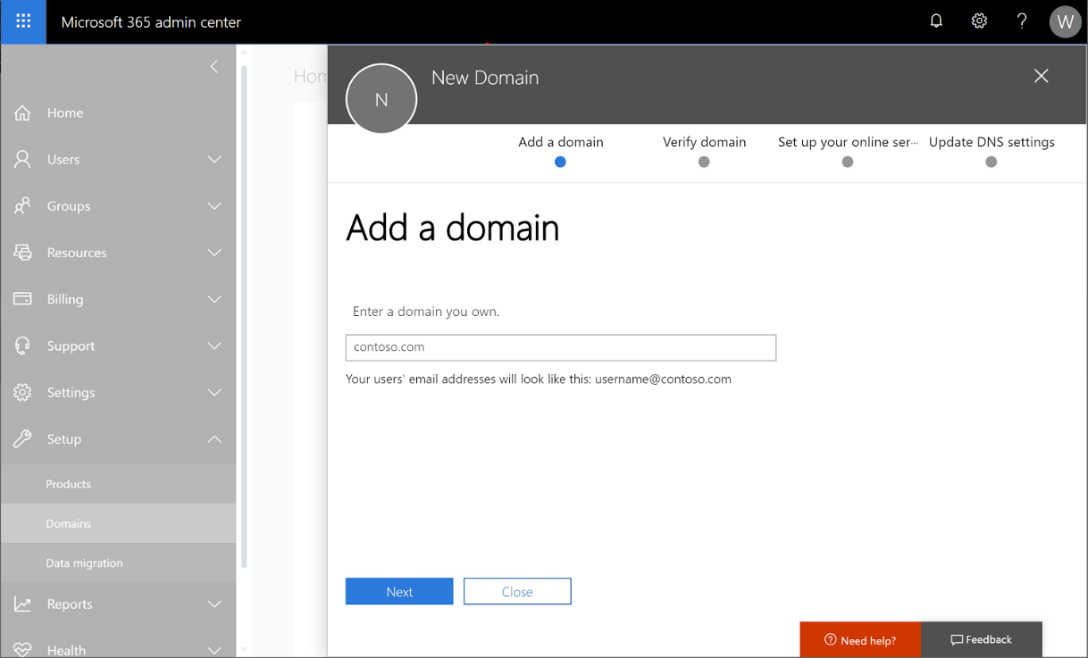

1. Verify that you are the owner of the domain that you entered in the previous step.

Selecting **send code via email** will send an email to the registered contact of your domain. After you receive the email, copy the code and enter it in the field labeled **Type your verification code here**. If the verification code matches, the domain will be added to your tenant. The email displayed may not look familiar. Some registrars hide the real email address. Also, the email address may be different then what was provided when the domain was registered.

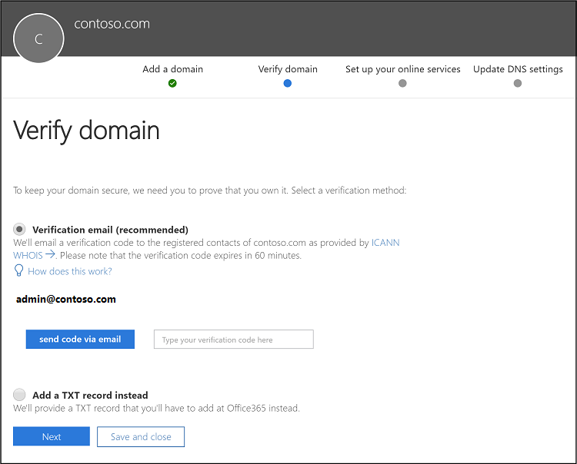

**Note**

For TXT record verification details, see [**Create DNS records at any DNS hosting provider for Microsoft 365**](https://support.office.com/article/Create-DNS-records-at-any-DNS-hosting-provider-for-Office-365-7B7B075D-79F9-4E37-8A9E-FB60C1D95166).

**Confirm your licenses**

A Microsoft Intune license is created for you when you sign up for the Intune free trial. As part of this trial, you'll also have a trial Enterprise Mobility + Security (EMS) subscription. An Enterprise Mobility + Security (EMS) subscription includes both Azure Active Directory Premium and Microsoft Intune.

To confirm your Azure Active Directory Premium and Microsoft Intune, see [Confirm your licenses](https://docs.microsoft.com/en-us/mem/intune/fundamentals/licenses#confirm-your-licenses).

**Admin experiences**

There are two portals that you will use most often:

* The Microsoft Endpoint Manager admin center (<https://endpoint.microsoft.com/>) is where you can explore the [capabilities of Intune](https://docs.microsoft.com/en-us/mem/intune/fundamentals/what-is-intune). This is where an admin would work with Intune.
* The Microsoft 365 admin center ([https://admin.microsoft.com](https://admin.microsoft.com/)) is where you can add and manage users, if you are not using Azure Active Directory for this. You can also manage other aspects of your account, including billing and support.